Maps and Scale Drawings-Questions
Key Stage 3: 2003 Paper 2 Level 3-5
1.
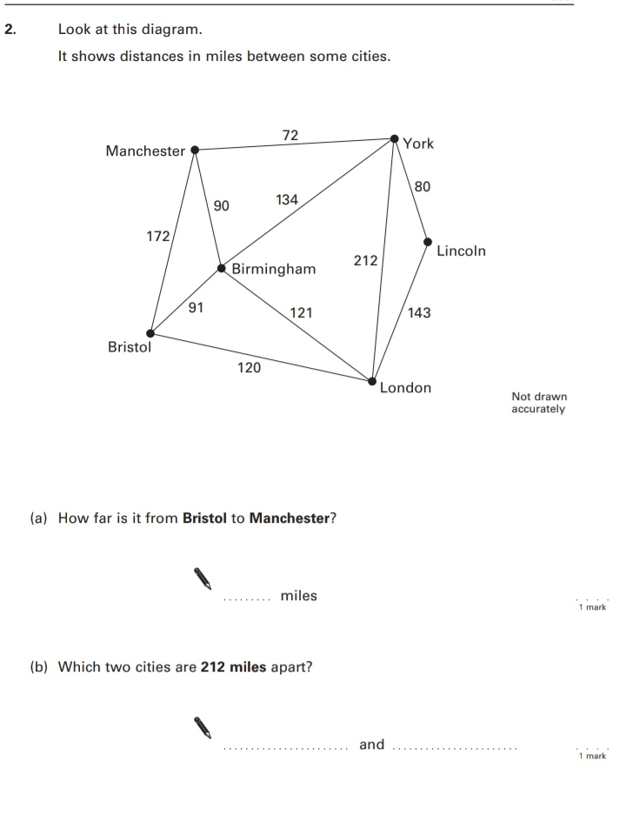
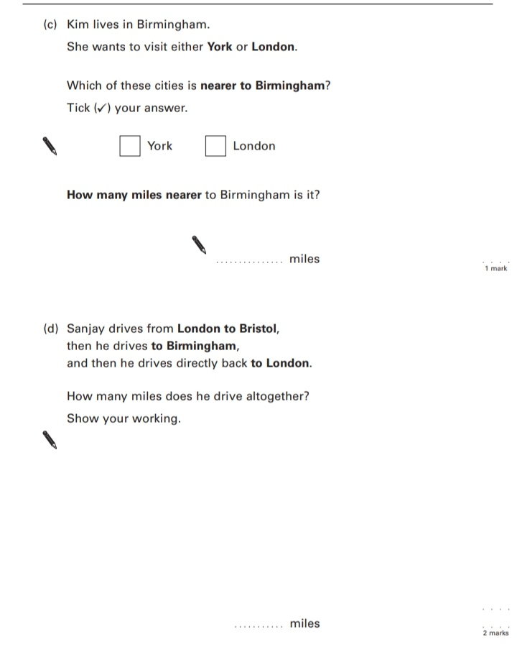
Key Stage 3: 2004 Paper 2 Level 3-5
2.
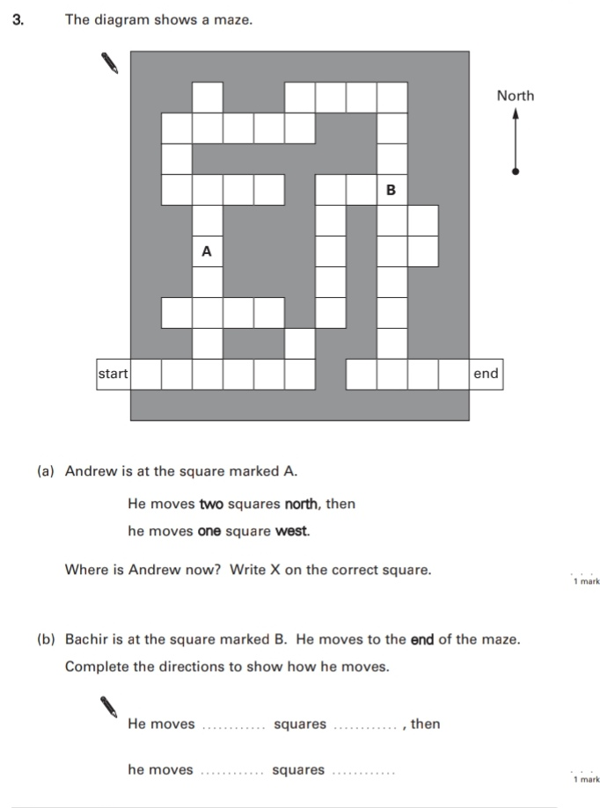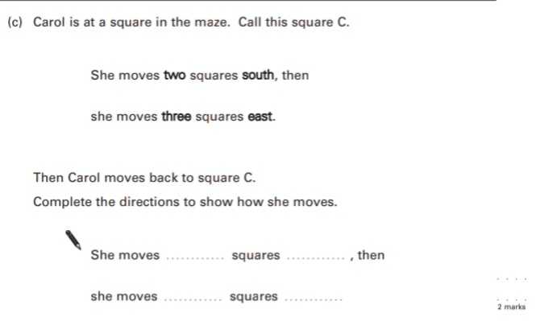
Key Stage 3: 2005 Paper 2 Level 3-5
3.
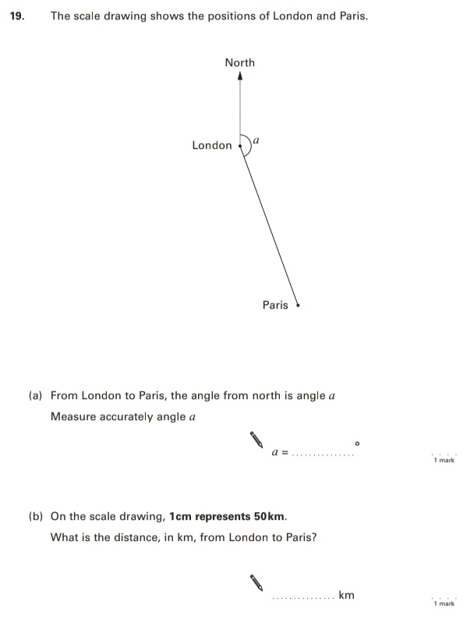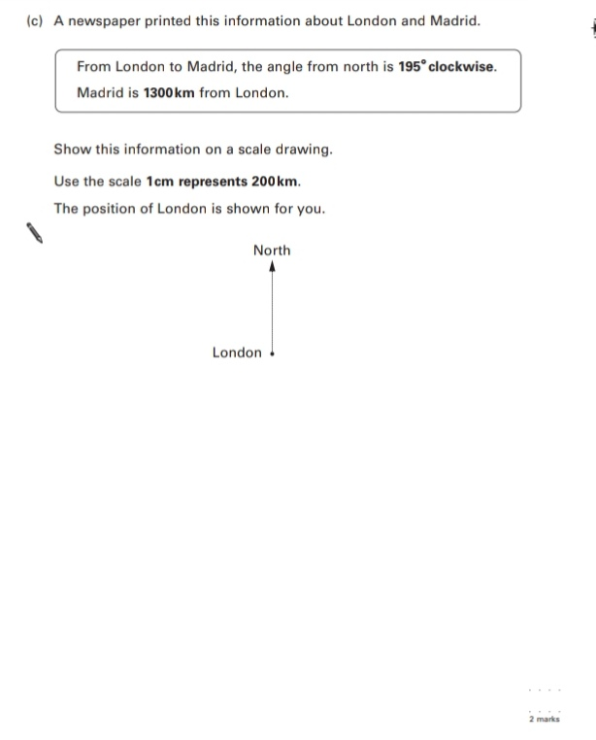
Key Stage 3: 2005 Paper 2 Level 4-6
4.
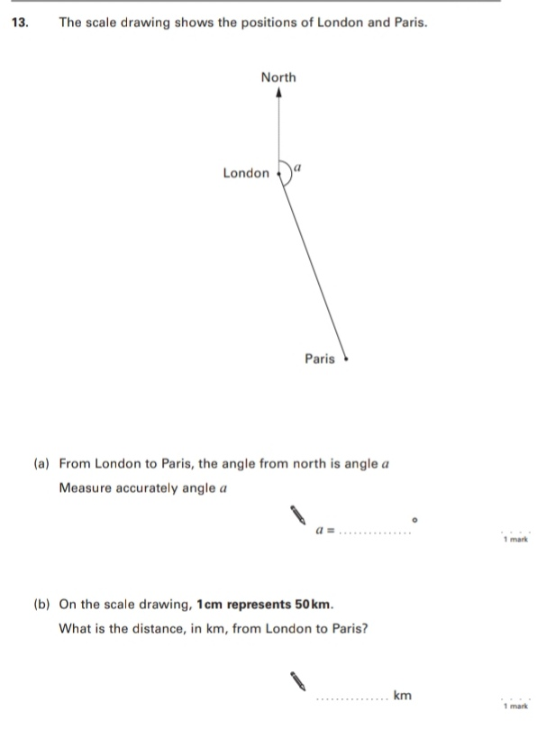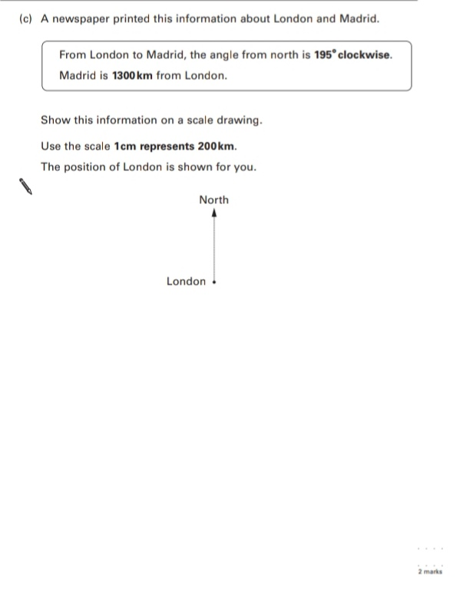
Key Stage 3: 2006 Paper 2 Level 3-5
5.
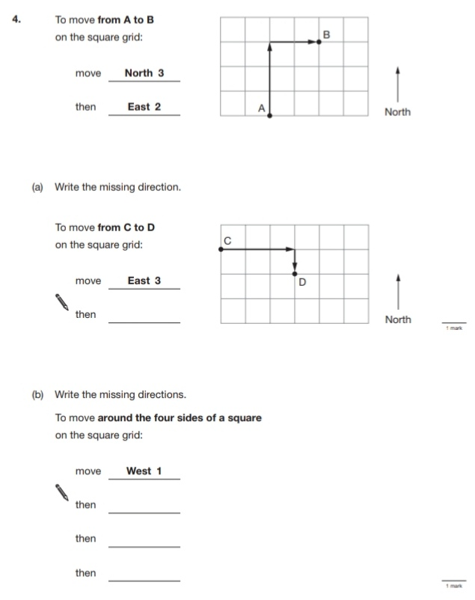
Key Stage 3: 2008 Paper 2 Level 3-5
6.
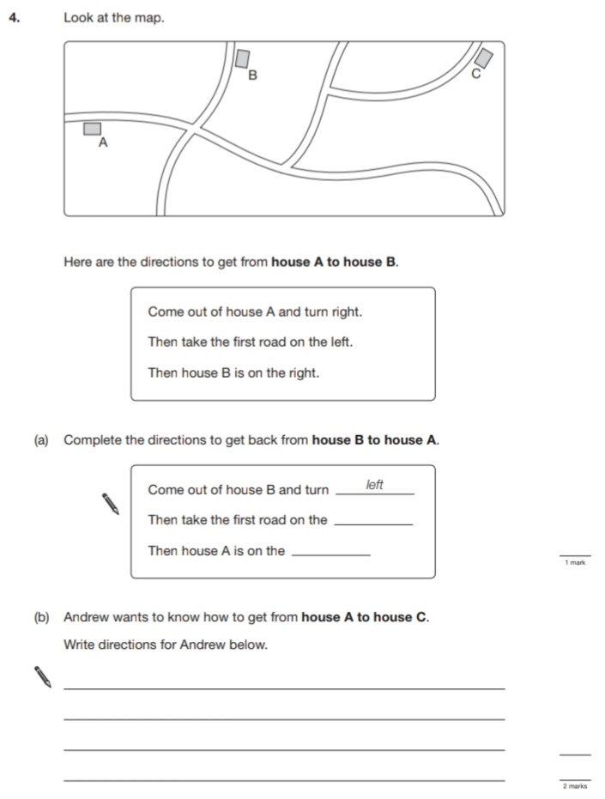
Key Stage 3: 2011 Paper 1 Level 4-6
7.
